**MANDATORY HANDS-ON**

**Question No: 9**

1. **List of Players**

**OUTPUT:**

**2.IndianPlayers**

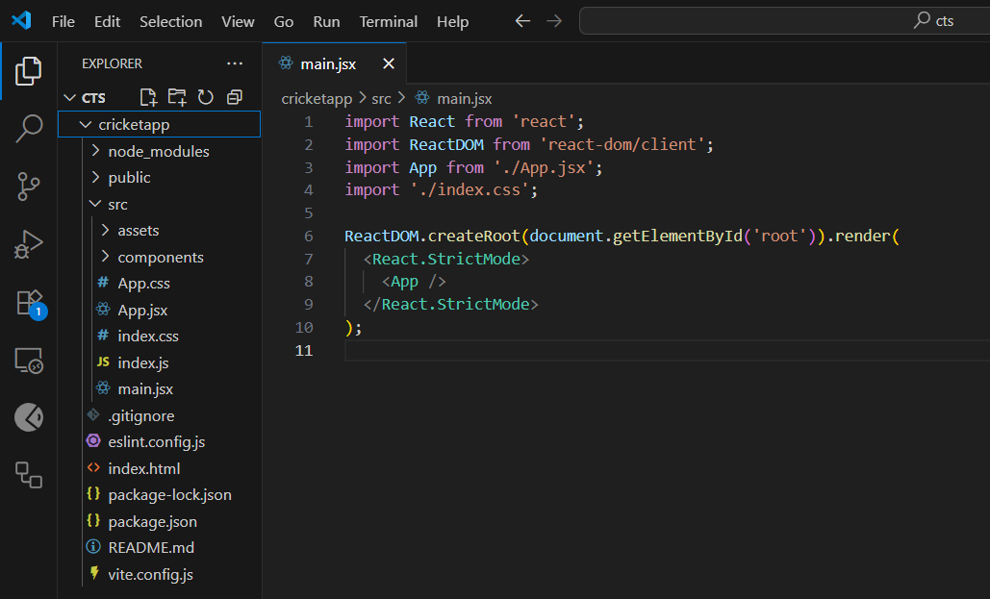

**OUTPUT:**

**QUESTION NO:10**

**React Application named “offices pace rental app”**

**OUTPUT:**

**QUESTION NO: 11**

**Create a React Application “event examples app”**

1. **Create “Increment” button to increase the value of the counter and “Decrement” button to decrease the value of the counter. The “Increase” button should invoke multiple methods.** 
   1. **To increment the value**
   2. **Say Hello followed by a static message.**

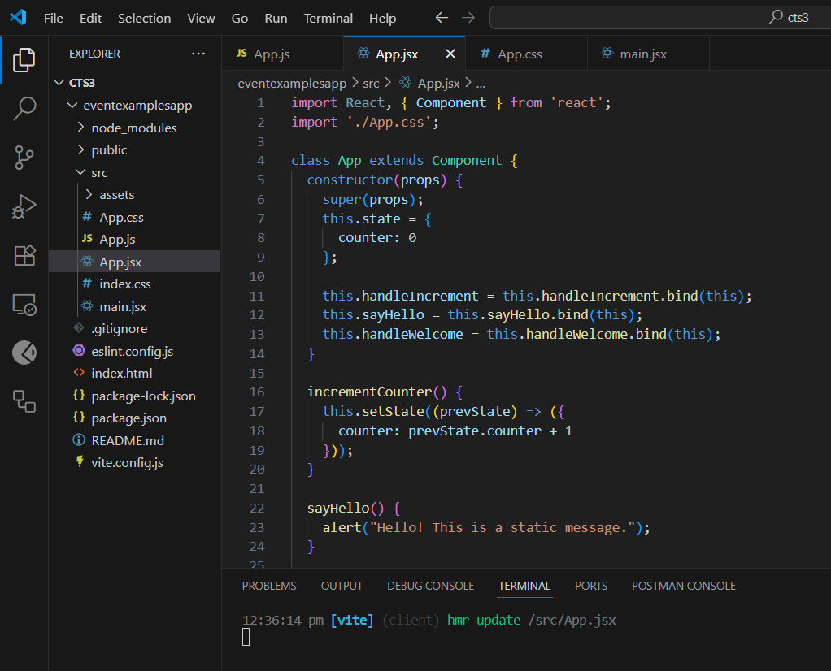

**OUTPUT:**

**2.Create a button “Say Welcome” which invokes the function which takes “welcome” as an argument.**

**OUTPUT:**

**3.Create a button which invokes synthetic event “On Press” which display “I was clicked”**

**OUTPUT:**

**4. Create a “Currency Convertor” component which will convert the Indian Rupees to Euro when the Convert button is clicked.**

**OUTPUT:**

**QUESTION NO:12**

**Create a React Application named “ticket booking app” where the guest user can browse the page where the flight details are displayed whereas the logged in user only can book tickets.**

**OUTPUT:**

**QUESTION NO:13**

**Create a React App named “bloggerapp” in with 3 components.**

1. **Book Details**
2. **Blog Details**
3. **Course Details**

**OUTPUT:**

